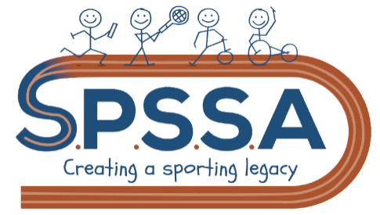
Partnership Sporting Pledge 2020-2021
We, the child, the teacher, the official and the spectator, shall show good sporting behaviour towards everyone. We pledge to have respect every day, in every sport and for everyone. Accepting victory and defeat graciously, treating everyone fairly, speaking considerately and politely and accepting official’s rules and decisions without complaining. We shall abide by the rules of the event. We shall applaud achievements and perseverance, giving positive comments throughout, to competitors, officials, teachers and spectators.
Don’t be the one, to spoil the fun.
School: Head teacher Signature:
Date:

