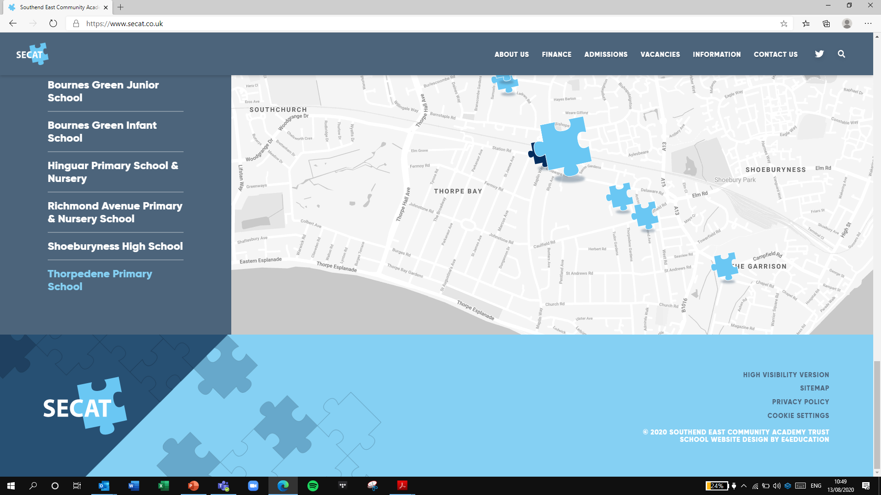
Building Strong schools
Building Strong partnerships
Building Strong communities
SOUTHEND EAST COMMUNITY ACADEMY TRUST

Dear Parent/Carer,

Your child is eligible for free Winter activities this year.
We would like to invite your child to 3 days of activities on:
Wednesday 21st December
Thursday 22nd December
Friday 23rd December
Time: 9am-1pm each day

Start Reception/KS1 –  9-9.30am | Start year 3/4 – 9-9.30am | Start year 5/6/Secondary -9-9.30am
Finish Reception/ KS1- 12.50am | Finish year 3/4 – 12.55am | Finish year 5/6/Secondary- 1pm

Venue: Shoeburyness High School (main reception side access gate will be the drop off and pick up points at the times above)

The children will be provided with a FREE breakfast, FREE healthy snack, and hot lunch for FREE.

During the day they will be able to take part in sport, art and music/drama which will be provided by teaching staff from across SECAT.

Please make sure children bring any medical information if needed and a refillable bottle if they have one. Wearing trainers and suitable clothes for sport would be advised. Also, warm clothes as some of the activities will be outside.

We have 40 places available each day please book via: https://secat.coordinate.cloud/project/36812 or you can book via the Livewell site
Kirk Edwards

Southend PE & School Sport Manager
Shoeburyness High School
kirkedwards@secat.co.uk Mobile: (07771) 847919

