**High 5 Netball Rules**

**Team Criteria:**

* 7-9 players in a squad
* Maximum of 3 boys in the squad
* Squad should consist of a minimum of 7 and a maximum of 9 players with 5 on court at any one time. Teams that have less than 7 in the squad may take part in friendly matches , but their scores will not count in the competition.

**Format:**

The squad is made up with the following playing positions GS GA C GD GK as well as scorers/time keeper and centre pass marker who have taken on these roles when off court.

**Rules:**

5-a-side - normal court markings

Size 4 ball

2,74m (9ft) post

Pass or shoot within 4 seconds

High 5 Netball provides the link between First Step Netball and the full 7-a-side rules. The rules have been modified to allow players greater freedom around the court and to give them more time in which to make their decisions and to act upon them. The game encourages maximum participation from those involved and introduces the roles of scorers, timekeepers and centre pass markers.

England Netball believe the game sits well with the requirement of Key Stage 2 of the National Curriculum for girls and boys in Years 5 and 6, (aged 9-11 years) and it is the only game to be played by players of this age.

**The Court:**

5 members of the squad are on court at any one time and are allowed in the following areas:

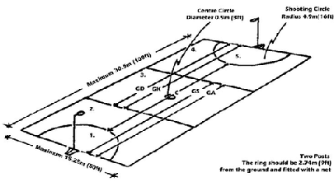

**Scorers:**

Keep a simple score card for their own team.

**Timekeeper:**

5 minutes each way – Timekeeper to indicate to the umpire when each half is finished – Calling TIME.

**Centre Pass Marker:**

Keep a note of whose centre pass it is and indicate to the umpire after each goal is scored and at the beginning of the second half.

**Duration of the game:**

Matches should be 5 minutes each way with 2 minutes at each interval during which squad members’ positions are rotated. Substitutions may be made at any time in the event of illness or injury.

**Rotation patterns:**

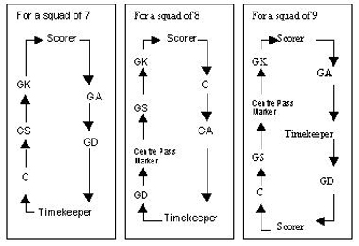

A rotation pattern must allow for all players have been off court at one time throughout the rotation.

No player should ever be off court consecutively

Rotation patterns will be continuous through both the matches being played and the tournament in which teams are playing

**Start of Play:**

Team Captains toss a coin to determine who takes the first Centre Pass. Subsequent centre passes must be taken alternately.

Play is started by a pass from the ‘Centre’, who stands with both feet in the centre circle.

At the start of play the GS, GA, GD and GK may be anywhere in the goal third. The opposing Centre shall be in the centre third and free to move.

When the umpire blows the whistle, the Centre must pass the ball within 4 seconds and obey the Footwork rule. The ball must be caught or touched in the centre third.

**Playing the Ball:**

***A player must:***

a.Pass or shoot within 4 seconds;   
b. Obey the footwork rule;

***A player may not:***

a. Deliberately kick the ball;   
b. Bounce the ball more than once;   
c. Hand or roll the ball to another player;   
d. Place their own hands on a ball held by an opponent;   
e. Throw the ball while sitting/lying on the ground;   
f. Use the goalpost as a support in receiving a ball going out of court or to gain balance;   
g. Throw the ball over a complete third without it being touched or caught by another player in that third;   
h. Regain possession of the ball, having dropped or thrown it, before it has been touched by another player.   
*Penalty:* ***Free Pass.***

**Footwork Rule:**

**a.** A player may receive the ball with one foot grounded or may jump to catch the land on one foot. While that landing foot remains on the ground the other foot may be moved in any direction and any number of times, pivoting on the landing foot if desired. Hopping is not allowed.   
**b.** A player may receive the ball whilst both feet are grounded, or may jump to catch and land on both feet simultaneously. The player may then chose to move either foot and the remaining foot shall then be considered to be the landing foot. Proceed as in a) above.   
Penalty: Free Pass.

**Scoring a Goal:**

A goal may only be scored by the Goal Shooter or the Goal Attack from within the shooting circle.

**Obstruction:**

The player with the ball must be permitted an unimpeded throwing or shooting action. One jump to intercept a throw or shot at goal is permitted provided that the player is at least 1m away and that the arms are not outstretched prior to the jump. Jumping up and down in front of a player is not permitted.   
*Penalty:* ***Penalty Pass or Shot***

**Contact:**

No player shall knock or push an opponent or interfere with his/her play, either accidentally or deliberately.     
*Penalty:* ***Penalty Pass or Shot***

**Out of Court:**

A ball is out of court when it, or a player touching it, touches the ground or an object outside the court. The line counts as part of the court. If the ball hits the post and bounces back into court, it is still in play.

**The Throw-in:**

The throw-in is taken at the point where the ball crossed the line. Any player allowed in that part of the court may take the throw-in and must stand outside the court with both feet behind the line. When the player taking the throw-in has checked that all other players are on court, she/he must release the ball within 4 seconds.

**Offside:**

A player is offside if she/he enters any area of the court in which she/he is not allowed.   
*Penalty:* ***Free Pass***

Substitutions may be made at any time in the event of illness or injury. There is no injury time. Team managers must assess within 30 seconds whether a player can continue. If s/he cannot continue the substitute must come on in the position vacated.

In the event that the player cannot continue a none playing position should be removed from the rotation. If they are able to continue then the squad is to revert back to the original rotation.